**Program no:3**

**Aim**:

Design a simple Calculator using GridLayout and Cascaded LinearLayout

XML Code

<?xml version="1.0" encoding="utf-8"?>

<androidx.constraintlayout.widget.ConstraintLayout xmlns:android="http://schemas.android.com/apk/res/android"

xmlns:app="http://schemas.android.com/apk/res-auto"

xmlns:tools="http://schemas.android.com/tools"

android:layout_width="match_parent"

android:layout_height="match_parent"

android:background="#D3C54D"

android:textAlignment="center"

tools:context=".MainActivity">

<TextView

android:id="@+id/rs"

android:layout_width="194dp"

android:layout_height="31dp"

android:textAlignment="center"

android:textAllCaps="true"

android:textSize="24sp"

android:textStyle="bold"

app:layout_constraintBottom_toBottomOf="parent"

app:layout_constraintHorizontal_bias="0.847"

app:layout_constraintLeft_toLeftOf="parent"

app:layout_constraintRight_toRightOf="parent"

app:layout_constraintTop_toTopOf="parent"

app:layout_constraintVertical_bias="0.098" />

<TextView

android:id="@+id/textView3"

android:layout_width="281dp"

android:layout_height="43dp"

android:text="Calculator"

android:textAlignment="center"

android:textAllCaps="true"

android:textSize="34sp"

android:textStyle="bold"

app:layout_constraintBottom_toBottomOf="parent"

app:layout_constraintHorizontal_bias="0.562"

app:layout_constraintLeft_toLeftOf="parent"

app:layout_constraintRight_toRightOf="parent"

app:layout_constraintTop_toTopOf="parent"

app:layout_constraintVertical_bias="0.022" />

<TextView

android:id="@+id/opp"

android:layout_width="320dp"

android:layout_height="32dp"

android:textAlignment="textEnd"

android:textAllCaps="true"

android:textSize="20sp"

app:layout_constraintBottom_toBottomOf="parent"

app:layout_constraintEnd_toEndOf="parent"

app:layout_constraintHorizontal_bias="0.637"

app:layout_constraintStart_toStartOf="parent"

app:layout_constraintTop_toTopOf="parent"

app:layout_constraintVertical_bias="0.175" />

<androidx.gridlayout.widget.GridLayout

android:layout_width="372dp"

android:layout_height="510dp"

android:layout_marginStart="2dp"

android:layout_marginTop="16dp"

android:layout_marginEnd="2dp"

android:layout_marginBottom="17dp"

app:layout_constraintBottom_toBottomOf="parent"

app:layout_constraintEnd_toEndOf="parent"

app:layout_constraintStart_toStartOf="parent"

app:layout_constraintTop_toBottomOf="@+id/opp">

<Button

android:id="@+id/ac"

android:layout_width="126dp"

android:layout_height="62dp"

android:onClick="clear"

android:text="AC"

app:layout_column="0"

app:layout_row="5"

tools:text="AC" />

<Button

android:id="@+id/clear"

android:layout_width="126dp"

android:layout_height="62dp"

android:onClick="clear"

android:text="C"

app:layout_column="2"

app:layout_row="5"

tools:text="C" />

<Button

android:id="@+id/n9"

android:layout_width="130dp"

android:layout_height="90dp"

android:onClick="nine"

android:text="9"

app:layout_column="0"

app:layout_row="0" />

<Button

android:id="@+id/equal"

android:layout_width="126dp"

android:layout_height="62dp"

android:onClick="equal"

android:text="="

app:layout_column="1"

app:layout_row="5" />

<Button

android:id="@+id/per"

android:layout_width="130dp"

android:layout_height="90dp"

android:onClick="per"

android:text="%"

app:layout_column="2"

app:layout_row="4" />

<Button

android:id="@+id/div"

android:layout_width="130dp"

android:layout_height="90dp"

android:onClick="div"

android:text="/"

app:layout_column="1"

app:layout_row="4" />

<Button

android:id="@+id/sub"

android:layout_width="130dp"

android:layout_height="90dp"

android:onClick="sub"

android:text="-"

app:layout_column="2"

app:layout_row="3" />

<Button

android:id="@+id/mul"

android:layout_width="130dp"

android:layout_height="90dp"

android:onClick="mul"

android:text="*"

app:layout_column="0"

app:layout_row="4" />

<Button

android:id="@+id/sum"

android:layout_width="130dp"

android:layout_height="90dp"

android:onClick="add"

android:text="+"

app:layout_column="1"

app:layout_row="3" />

<Button

android:id="@+id/n0"

android:layout_width="130dp"

android:layout_height="90dp"

android:onClick="zero"

android:text="0"

app:layout_column="0"

app:layout_row="3" />

<Button

android:id="@+id/n1"

android:layout_width="130dp"

android:layout_height="90dp"

android:onClick="one"

android:text="1"

app:layout_column="2"

app:layout_row="2" />

<Button

android:id="@+id/n2"

android:layout_width="130dp"

android:layout_height="90dp"

android:onClick="two"

android:text="2"

app:layout_column="1"

app:layout_row="2" />

<Button

android:id="@+id/n3"

android:layout_width="130dp"

android:layout_height="90dp"

android:onClick="three"

android:text="3"

app:layout_column="0"

app:layout_row="2" />

<Button

android:id="@+id/n4"

android:layout_width="130dp"

android:layout_height="90dp"

android:onClick="four"

android:text="4"

app:layout_column="2"

app:layout_row="1" />

<Button

android:id="@+id/n5"

android:layout_width="130dp"

android:layout_height="90dp"

android:onClick="five"

android:text="5"

app:layout_column="1"

app:layout_row="1" />

<Button

android:id="@+id/n6"

android:layout_width="130dp"

android:layout_height="90dp"

android:onClick="six"

android:text="6"

app:layout_column="0"

app:layout_row="1" />

<Button

android:id="@+id/n7"

android:layout_width="130dp"

android:layout_height="90dp"

android:onClick="seven"

android:text="7"

app:layout_column="2"

app:layout_row="0" />

<Button

android:id="@+id/n8"

android:layout_width="130dp"

android:layout_height="90dp"

android:onClick="eight"

android:text="8"

app:layout_column="1"

app:layout_row="0" />

</androidx.gridlayout.widget.GridLayout>

</androidx.constraintlayout.widget.ConstraintLayout>

Java Code

package com.example.co2_q2;

import androidx.appcompat.app.AppCompatActivity;

import android.os.Bundle;

import android.view.View;

import android.widget.TextView;

public class MainActivity extends AppCompatActivity {

float mValueOne, mValueTwo;

boolean cAddition, mSubtract, cMultiplication, cDivision,cperc;

TextView op,rss;

@Override

protected void onCreate(Bundle savedInstanceState) {

super.onCreate(savedInstanceState);

setContentView(R.layout.activity_main);

op = findViewById(R.id.opp);

rss = findViewById(R.id.rs);

}

public void zero(View view){

op.setText(op.getText() + "0");

}

public void one(View view){

op.setText(op.getText() + "1");

}

public void two(View view){

op.setText(op.getText() + "2");

}

public void three(View view){

op.setText(op.getText() + "3");

}

public void four(View view){

op.setText(op.getText() + "4");

}

public void five(View view){

op.setText(op.getText() + "5");

}

public void six(View view){

op.setText(op.getText() + "6");

}

public void seven(View view){

op.setText(op.getText() + "7");

}

public void eight(View view){

op.setText(op.getText() + "8");

}

public void nine(View view){

op.setText(op.getText() + "9");

}

public void add(View view){

if (op == null) {

op.setText("");

} else {

mValueOne = Float.parseFloat(op.getText() + "");

cAddition = true;

op.setText(null);

}

}

public void sub(View view){

if (op == null) {

op.setText("");

} else {

mValueOne = Float.parseFloat(op.getText() + "");

mSubtract = true;

op.setText(null);

}

}

public void mul(View view){

if (op == null) {

op.setText("");

} else {

mValueOne = Float.parseFloat(op.getText() + "");

cMultiplication = true;

op.setText(null);

}

}

public void div(View view){

if (op == null) {

op.setText("");

} else {

mValueOne = Float.parseFloat(op.getText() + "");

cDivision = true;

op.setText(null);

}

}

public void per(View view){

if (op == null) {

op.setText("");

} else {

mValueOne = Float.parseFloat(op.getText() + "");

cperc = true;

op.setText(null);

}

}

public void equal(View view){

if (op == null) {

op.setText("");

} else {

mValueTwo = Float.parseFloat(op.getText() + "");

if (cAddition == true) {

op.setText(Float.toString(mValueOne)+" + "+Float.toString(mValueTwo)+" = "+Float.toString(mValueOne + mValueTwo) + "");

}

else if (mSubtract == true) {

op.setText(Float.toString(mValueOne)+" - "+Float.toString(mValueTwo)+" = "+Float.toString(mValueOne - mValueTwo) + "");

}

else if (cMultiplication == true) {

op.setText(Float.toString(mValueOne)+" * "+Float.toString(mValueTwo)+" = "+Float.toString(mValueOne * mValueTwo )+ "");

}

else if (cDivision == true) {

op.setText(Float.toString(mValueOne)+" / "+Float.toString(mValueTwo)+" = "+Float.toString(mValueOne / mValueTwo )+ "");

}

else if (cperc == true) {

op.setText(Float.toString(mValueOne)+" % "+Float.toString(mValueTwo)+" = "+Float.toString(mValueOne / mValueTwo*100)+"%");

}

cAddition = false;

mSubtract = false;

cMultiplication = false;

cDivision = false;

cperc = false;

mValueOne =0 ;

mValueTwo=0;

}

}

public void clear(View view){

cAddition = false;

mSubtract = false;

cMultiplication = false;

cDivision = false;

cperc = false;

mValueOne =0 ;

mValueTwo=0;

op.setText(null);

rss.setText(null);

}

}

OUTPUT

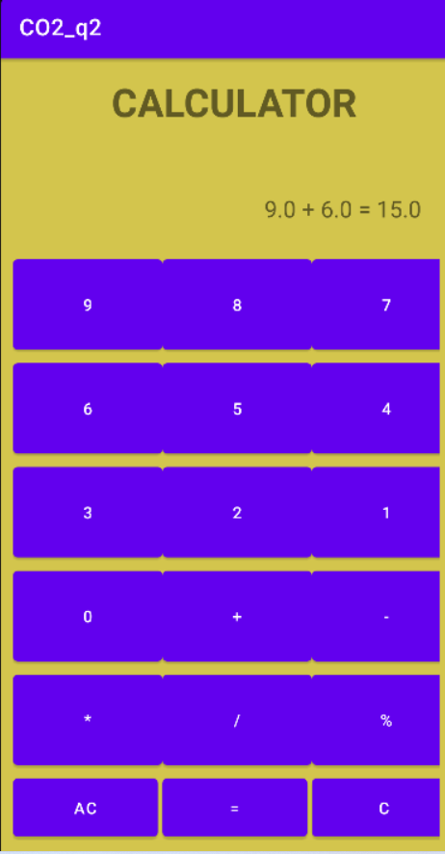

**Program no:4**

**Aim**:

Create a Facebook page using RelativeLayout; set properties using .xml file

XML code:

<?xml version="1.0" encoding="utf-8"?>

<androidx.constraintlayout.widget.ConstraintLayout xmlns:android="http://schemas.android.com/apk/res/android"

xmlns:app="http://schemas.android.com/apk/res-auto"

xmlns:tools="http://schemas.android.com/tools"

android:layout_width="match_parent"

android:layout_height="match_parent"

android:background="#1b74f1"

tools:context=".MainActivity">

<RelativeLayout

android:id="@+id/relativeLayout"

android:layout_width="412dp"

android:layout_height="142dp"

app:layout_constraintBottom_toBottomOf="parent"

app:layout_constraintEnd_toEndOf="parent"

app:layout_constraintHorizontal_bias="0.0"

app:layout_constraintStart_toStartOf="parent"

app:layout_constraintTop_toTopOf="parent"

app:layout_constraintVertical_bias="0.004">

<ImageView

android:id="@+id/imageView"

android:layout_width="229dp"

android:layout_height="100dp"

android:layout_alignParentEnd="true"

android:layout_alignParentRight="true"

android:layout_marginEnd="117dp"

android:layout_marginRight="117dp"

app:srcCompat="@drawable/fblogo" />

</RelativeLayout>

<RelativeLayout

android:id="@+id/relativeLayout2"

android:layout_width="114dp"

android:layout_height="80dp"

app:layout_constraintBottom_toBottomOf="parent"

app:layout_constraintEnd_toEndOf="parent"

app:layout_constraintHorizontal_bias="0.025"

app:layout_constraintStart_toStartOf="parent"

app:layout_constraintTop_toTopOf="parent"

app:layout_constraintVertical_bias="0.341">

<ImageView

android:id="@+id/imageView2"

android:layout_width="84dp"

android:layout_height="72dp"

app:srcCompat="@drawable/prof_pic" />

</RelativeLayout>

<TextView

android:id="@+id/textView2"

android:layout_width="197dp"

android:layout_height="57dp"

android:textColor="@color/black"

android:text="Ashish Wilson "

app:layout_constraintBottom_toBottomOf="parent"

app:layout_constraintEnd_toEndOf="parent"

app:layout_constraintHorizontal_bias="0.64"

app:layout_constraintStart_toStartOf="parent"

app:layout_constraintTop_toTopOf="parent"

app:layout_constraintVertical_bias="0.351" />

<CheckBox

android:id="@+id/checkBox"

android:layout_width="242dp"

android:layout_height="39dp"

android:text="Log Into Another Account"

app:layout_constraintBottom_toBottomOf="parent"

app:layout_constraintEnd_toEndOf="parent"

app:layout_constraintHorizontal_bias="0.112"

app:layout_constraintStart_toStartOf="parent"

app:layout_constraintTop_toTopOf="parent"

app:layout_constraintVertical_bias="0.469" />

<CheckBox

android:id="@+id/checkBox2"

android:layout_width="262dp"

android:layout_height="45dp"

android:text="Find Your Account"

app:layout_constraintBottom_toBottomOf="parent"

app:layout_constraintEnd_toEndOf="parent"

app:layout_constraintHorizontal_bias="0.107"

app:layout_constraintStart_toStartOf="parent"

app:layout_constraintTop_toTopOf="parent"

app:layout_constraintVertical_bias="0.553" />

<EditText

android:id="@+id/editTextTextPersonName"

android:layout_width="310dp"

android:layout_height="52dp"

android:ems="10"

android:inputType="textPersonName"

android:text="CREATE NEW FACEBOOK ACCOUNT"

android:textColor="@android:color/white"

android:textColorLink="#1b74f1"

app:layout_constraintBottom_toBottomOf="parent"

app:layout_constraintEnd_toEndOf="parent"

app:layout_constraintHorizontal_bias="0.497"

app:layout_constraintStart_toStartOf="parent"

app:layout_constraintTop_toTopOf="parent"

app:layout_constraintVertical_bias="0.838" />

</androidx.constraintlayout.widget.ConstraintLayout>

OUTPUT

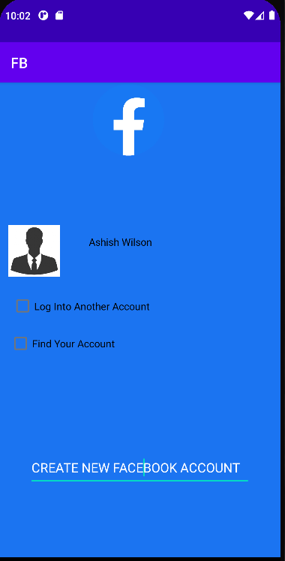

**Program no:5**

**Aim**:

Develop an application that toggles image using FrameLayout

XML Code:

<?xml version="1.0" encoding="utf-8"?>

<FrameLayout xmlns:android="http://schemas.android.com/apk/res/android"

xmlns:app="http://schemas.android.com/apk/res-auto"

xmlns:tools="http://schemas.android.com/tools"

android:layout_width="match_parent"

android:layout_height="match_parent"

android:background="#BDBABA"

tools:context=".MainActivity">

<ImageView

android:id="@+id/imageView1"

android:layout_width="427dp"

android:layout_height="wrap_content"

android:layout_gravity="left|top"

android:background="#CACAC8"

app:srcCompat="@drawable/s1" />

<ImageView

android:id="@+id/imageView2"

android:layout_width="396dp"

android:layout_height="wrap_content"

android:layout_gravity="left|top"

android:visibility="gone"

app:srcCompat="@drawable/b1" />

</FrameLayout>

Java Code

package com.example.frame;

import androidx.appcompat.app.AppCompatActivity;

import android.os.Bundle;

import android.view.View;

import android.widget.ImageView;

public class MainActivity extends AppCompatActivity implements View.OnClickListener {

ImageView i1,i2;

@Override

protected void onCreate(Bundle savedInstanceState) {

super.onCreate(savedInstanceState);

setContentView(R.layout.activity_main);

i1=(ImageView) findViewById(R.id.imageView1);

i2=(ImageView) findViewById(R.id.imageView2);

i1.setOnClickListener(this);

i2.setOnClickListener(this);

}

@Override

public void onClick(View v) {

if(v.getId()==R.id.imageView1)

{

i1.setVisibility(v.GONE);

i2.setVisibility(v.VISIBLE);

}

else

{

i2.setVisibility(v.GONE);

i1.setVisibility(v.VISIBLE);

}

}

}

OUTPUT

|  |  |
| --- | --- |